Certified Expert in Treasury and Markets

Programme Overview

Global Financial Markets have changed significantly during the last decade in terms of products, regulation and management. In order to respond to those changes the Frankfurt School of Finance and Management has developed in collaboration with AEFMA Germany e.V. a new education programme for financial markets and treasury.
Start  Intake anytime, self-paced learning  Duration  9-12 Month  Part-Time | Awarded  Frankfurt School Certificate  "Certified Expert in Treasury and Markets"  Equivalent to 15 ECTS

Objective

The objective of the programme Certified Expert in Treasury and Markets is to provide participants with in-depth practical and theoretical understanding of financial markets & products and treasury. Experts from the financial industry come together in order to learn, accelerate, discuss, question, and challenge. The programme starts with an e-learning part to build a fundamental knowledge in financial markets and their products which will be assessed by an examination. The programme continues with two alternative advanced on-campus workshops to provide a deeper understanding of financial markets topics.

Key Benefits

Understand the core concepts & principles of the financial markets & treasury management

Learn new skills and immediately apply the knowledge within your organisation

Acquire the latest tools and techniques

Connect with high-profile participants from all over the world and build long-lasting networks

Earn a certificate from one of Europe’s leading business schools

Learning Target

Participants will receive a profound knowledge in the topics Fixed Income, Risk Management, Derivatives, Foreign Exchange, Commodities, Asset & Liability Management as well as Regulation & Compliance. During the programme, different learning formats and various tools will give participants the possibility to apply their new knowledge and strengthen their skills. Additionally, candidates will get valuable feedback from experienced faculty members as well as from peers.

Target Groups and Industries
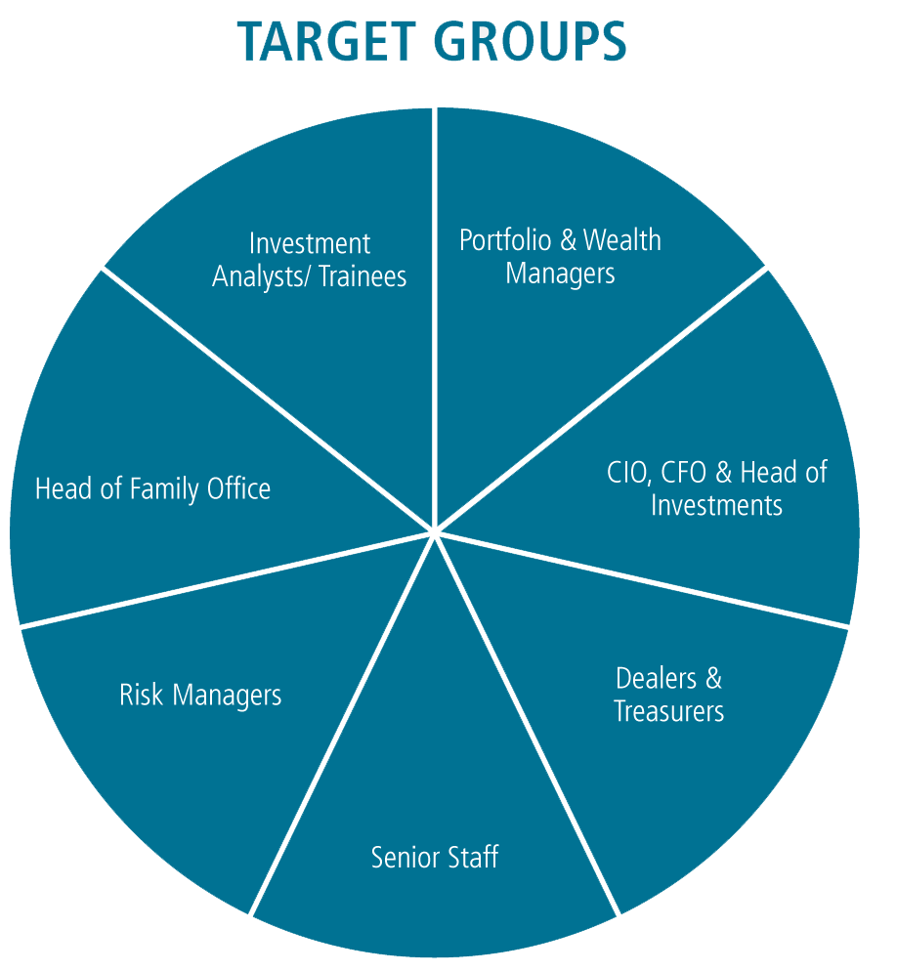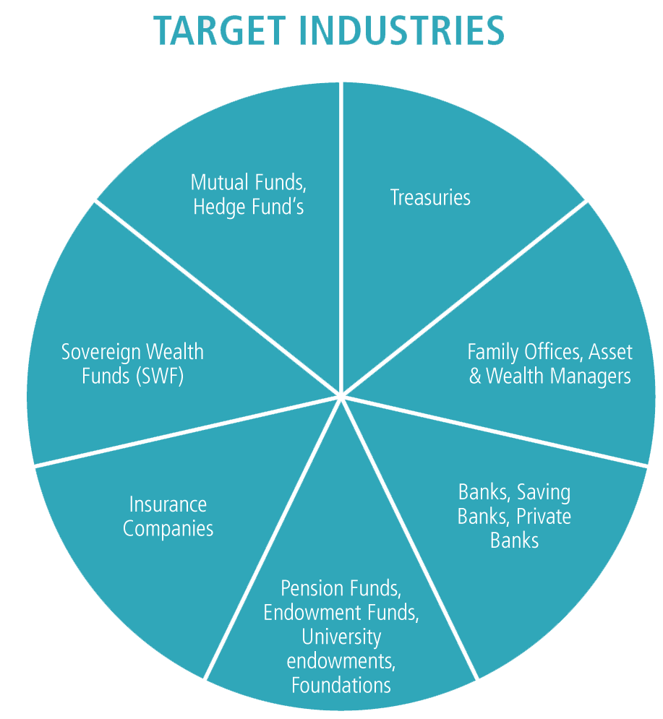
Curriculum
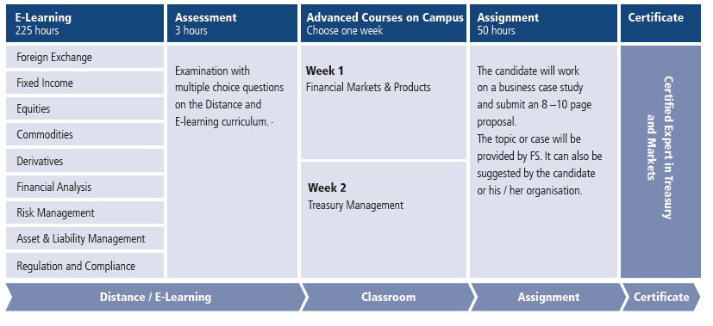
Foreign exchange  Product overview  Market conventions  Fundamental understanding of market data  FX structured products  Hedge accounting | Fixed income  Cash and derivative instruments  Modelling interest curves  Single Curve and Multi Curve  Bond pricing  Overview of international capital markets | Derivatives  Mathematical and statistical models  Linear products  Non-linear products  Complex derivatives  Structured Products
Commodities  Functionality and terminology of the  Commodity market  Energy, Metals  Agriculture / Food  Regulatory drivers of the Commodity market | Equities  Equity instruments  Fundamental drivers of equity  Dividend Models  Multiplier Models  Cashflow Valuation | Financial Analysis  Introduction to financial statements  Financial ratio analysis  Influence of business decisions on P/L,  balance sheet and cashflow statement  IFRS 7, 9, 13
Risk Management  Definition of risk and key historic events  Market Risk, Credit Risk  Value at Risk and Expected Shortfall  Option hedging  Credit Default Swaps  Operational and Liquidity Risk | Asset & Liability Management  Fundamentals of ALM  Interest Rate Risk in the Banking Book  Forex Exposures in the Banking Book  Liquidity Management  Portfolio Credit Risk | Regulation & Compliance  Basel III  MIFID II/ MiFIR  EMIR  Market Abuse Regulation  AIFMD & UCITS

Experts
- Prof. Dr. Uwe Wystup - Uwe Wystup is managing director of MathFinance AG. Before, he has actively worked in FX derivatives trading as Financial Engineer, Global Structured Risk Manager and Advisor since 1992, including Citibank, UBS, Sal. Oppenheim and Commerzbank.
- Dr. Achim Posthaus - Dr. Achim Posthaus is Founder and Managing Director of Alpha Pi Analytics GmbH as well as academic lecturer at the Frankfurt School of Finance and Management.
- Birgitta Drwenski - Birgitta currently works as a specialist in the Liquidity Advisory team in Commerzbank’s Group Treasury division. Prior to joining the treasury department, she worked as a director in the Fixed Income & Currency (FIC) area of Commerzbank’s Corporates & Markets division.
- Dr. Rene Lindloh - René holds a Ph.D. (Doktor rer. Nat.) in mathematics and worked as research assistant for hight dim. approximation problems. He is a Portfolio Manager with years of trading experience on the commodities markets.
- Dr. Joachim Bald - Dr. Bald is Frankfurt School’s most senior international advisor and a recognized expert in Treasury, Risk and Asset Liability Management. He serves as lead consultant at the Frankfurt School Competence Center in Risk Management and regularly manages complex implementation assignments in Europe, Asia and Africa.
- Carsten Auel - Carsten Auel, CFA is a Senior Manager at Deloitte and a recognized lecturer for Capital Markets, Investments, Securitizations, Fixed Income and Equity products. He is experienced in the pricing, financial modeling and risk analysis of plain vanilla as well as complex financial instruments. During his career, Carsten has managed a number of complex implementations of pricing and analysis platforms for prestigious clients.
Contact:
Silja Bellinger and Basel Chaban
Frankfurt School of Finance & Management gGmbH
International Advisory Services
Adickesallee 32-34, 60322 Frankfurt
ExecutiveEd@fs.de
+49 69 154008634
Website: www.fs.de\cetm

